FOR IMMEDIATE RELEASE! FOR IMMEDIATE RELEASE!
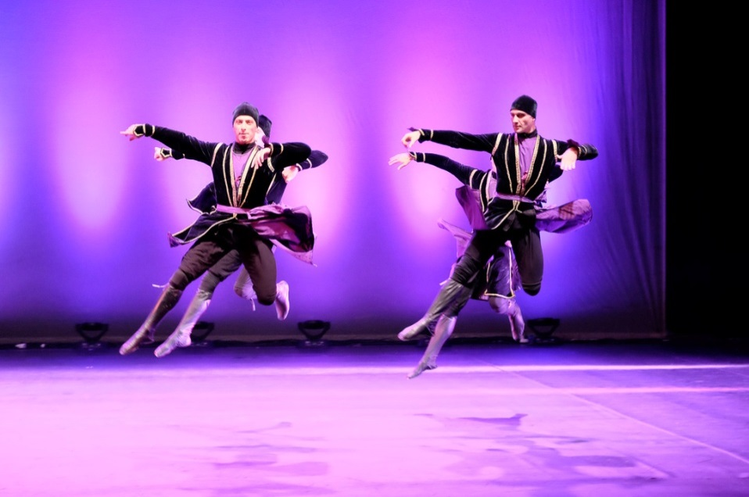
INTERNATIONAL CONCERTS presents SUKHISHVILI GEORGIAN NATIONAL BALLET 70 ANNIVERSARY JUBILEE PERFORMANCE,
SATURDAY, OCTOBER 3, 8:00 LOWER MORELAND AUDITORIUM, 555 RED LION RD, PHILADELPHIA

Fifty extraordinary, richly costumed dancers, accompanied by live musicians, perform an exciting program, featuring the most sensational pieces in the company’s repertoire.

Sukhishvili is acclaimed as one of the world’s foremost and most exciting dance companies. It has performed for fifty million people in eighty-eight countries on five continents and received accolades of praise from press and public universally. It has appeared at the Metropolitan Opera, Avery Fisher Hall, Madison Square Garden Albert Hall, the Rome Coliseum and La Scala where it received a record-breaking ovation and number of curtain calls. It was a headline attraction with New York City Ballet for the George Balanchine Centennial. Sukhishvili was honored with a Gold Medal from Queen Elizabeth, “Best Show of the Year Award” for its limited Broadway run. The New York Times called them “Downright terrific”; the Washington Post exclaimed they are “First, Foremost, and Magnificent!”.

Sukhishvili Georgian National Ballet was founded by Iliko Sukhishvili and Nino Ramishvili in 1945, the year that marked the end of World War II. The company’s surging expression of emotion and tradition reflects the adventure, spirit, and will of the Georgian people and is an emotion-packed evening that brings the story of Georgia, its great tragic history, artistry, humor, tradition, temperament and will.

Guest artists who appeared with the inaugural launch of the celebration in June 2015 include the famous Ballet Stars, Nina Ananiashvili, Ilse and Andris Liepa, Irma Nioradze, Dennis Kuznetsov.

Tickets begin at $40 - $85. Contact us at info@intlconcerts.org, (212)239-0494
